Documentation:

Field Note: Feb. 4 First Meeting

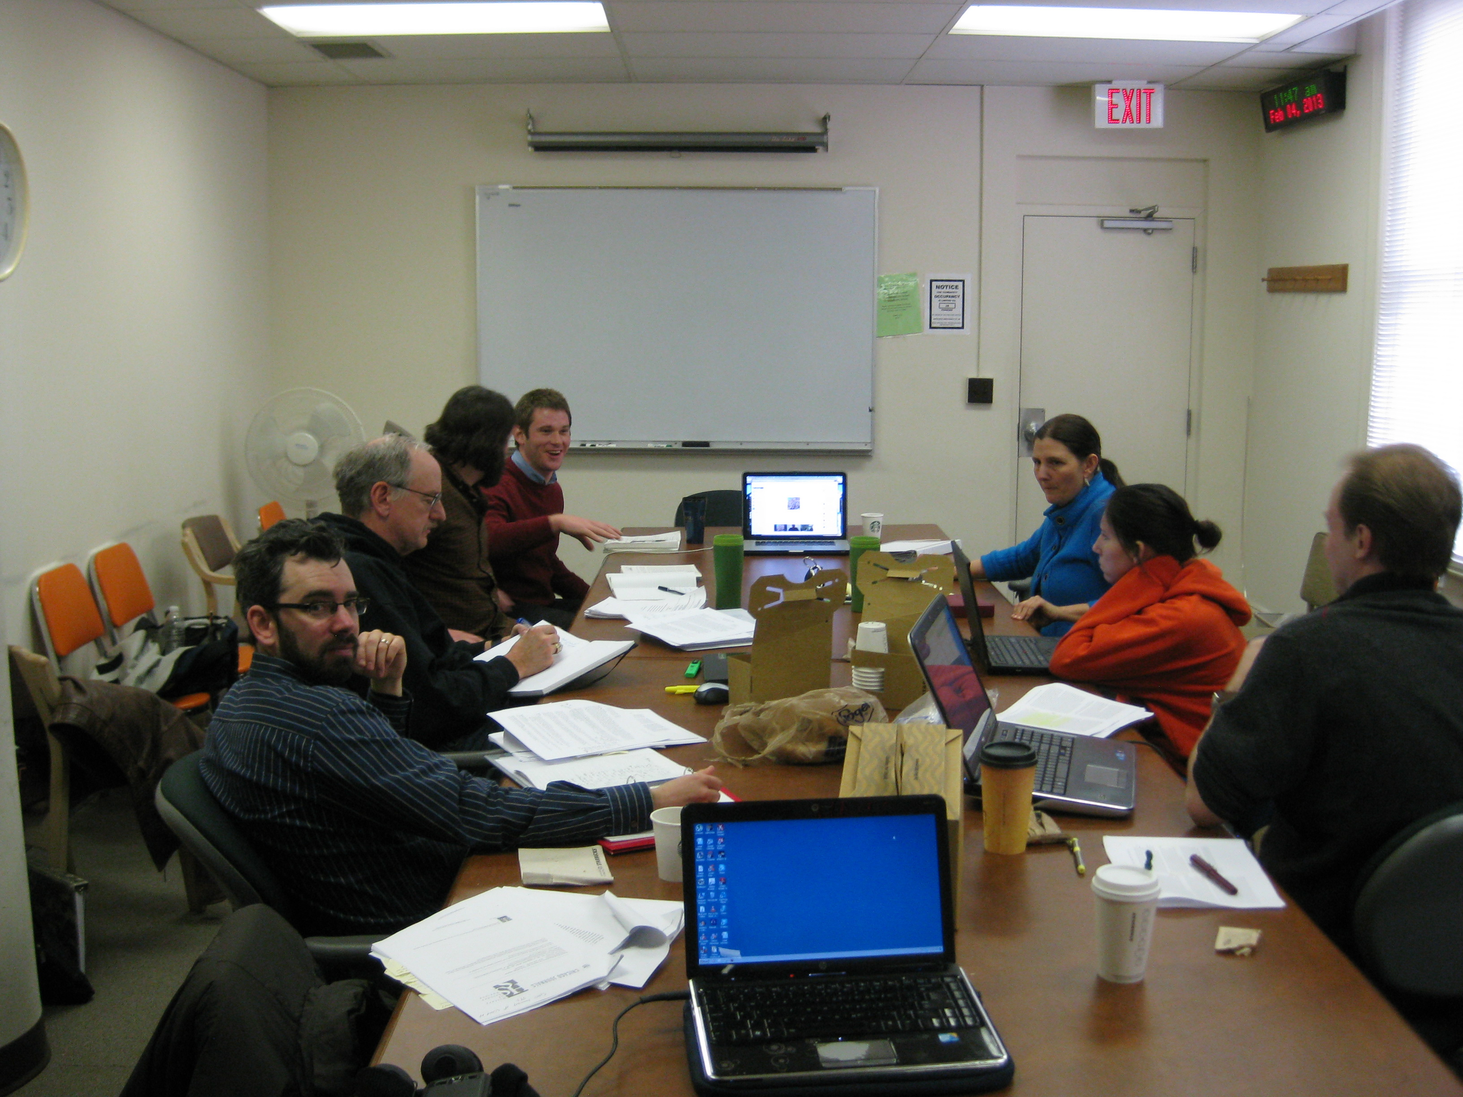

Our first meeting was really just a brainstorm of different directions we might want to go individually in researching normativity. Ideas thrown out on the table included facutly genealogies, research of different STS handbooks, oral histories with faculty members, general examination of norms in publications, etc. A few people decided to follow specific research ideas (such as the genealogies of different faculty members) while others wanted to think more about how they might approach the concept of normativity. We set a date to have more concrete ideas posted in the wiki within the week. We also agreed to look for different frameworks that might hold the narrative together, from digital tools (such as Google Maps and Pinterest) to more straightforward linear narratives written in the wiki.

One concern raised in the group was that our narrative would be made public via the Social Epistemology website. People expressed feelign somewhat intimidated that scholars would have access to our work online, and be able to comment on it, and because we wanted to include something we could be proud of as a publication.

Field Note: Feb. 11 Brainstorm Session

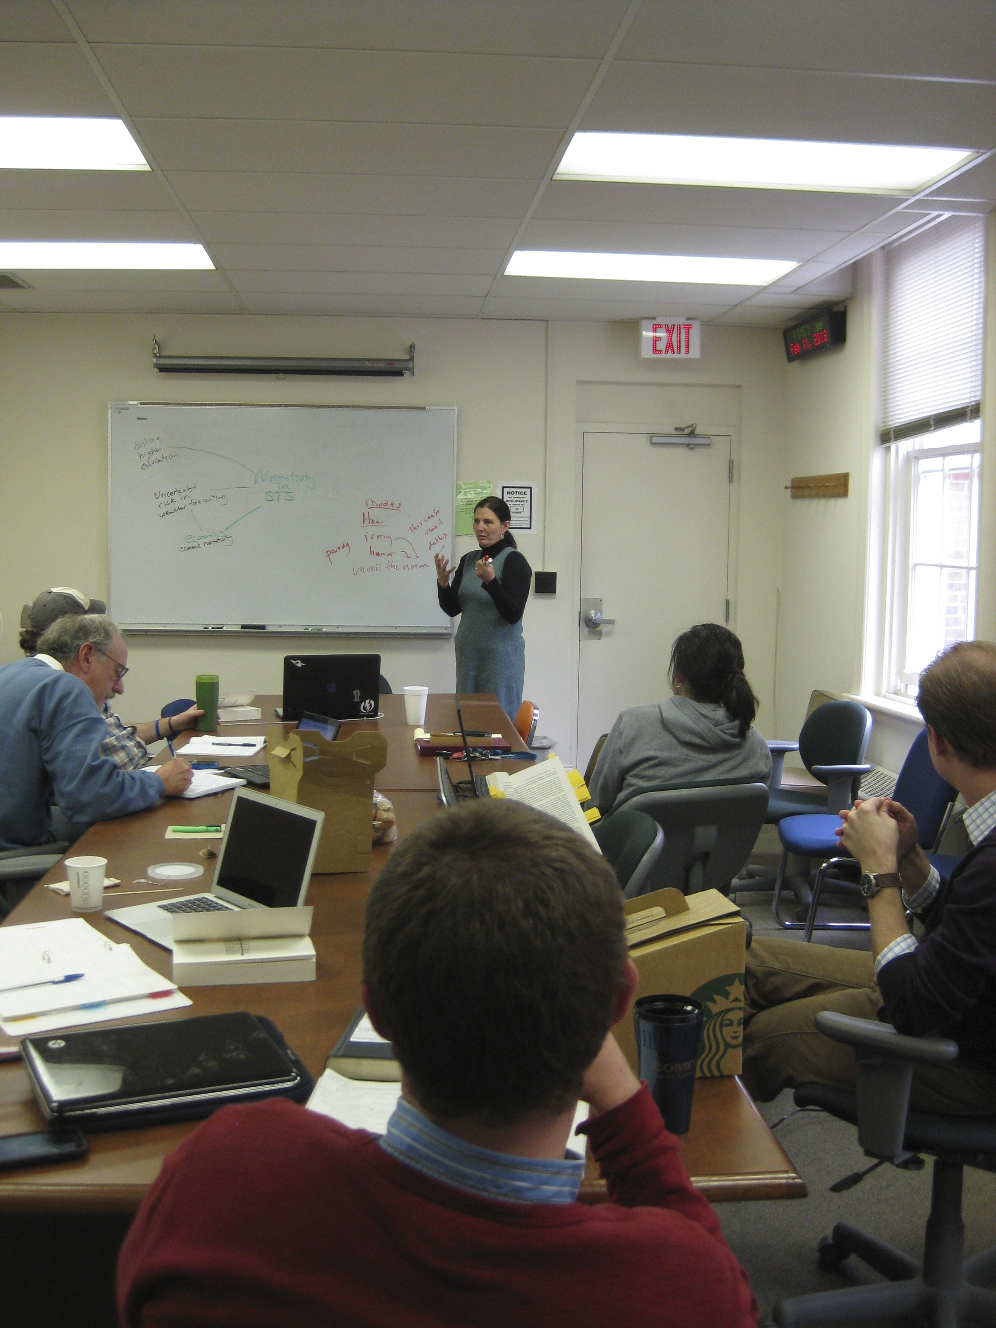
Feb. 11: Crystal leading the discussion of concept narrative

On this day, we began to brainstorm and map out the connections between our different appraoches. We were looking for trends or overarching themes that might tether our collective interests together, as well as those concrete approaches to the subject that we could being to explore. We discussed the role of silence, conflicts of interest, higher education, risk, and economics. In terms of modes of exploration, we raised the idea that irony, parady, and humor might be helpful to the project as a way to “unveil” norms.
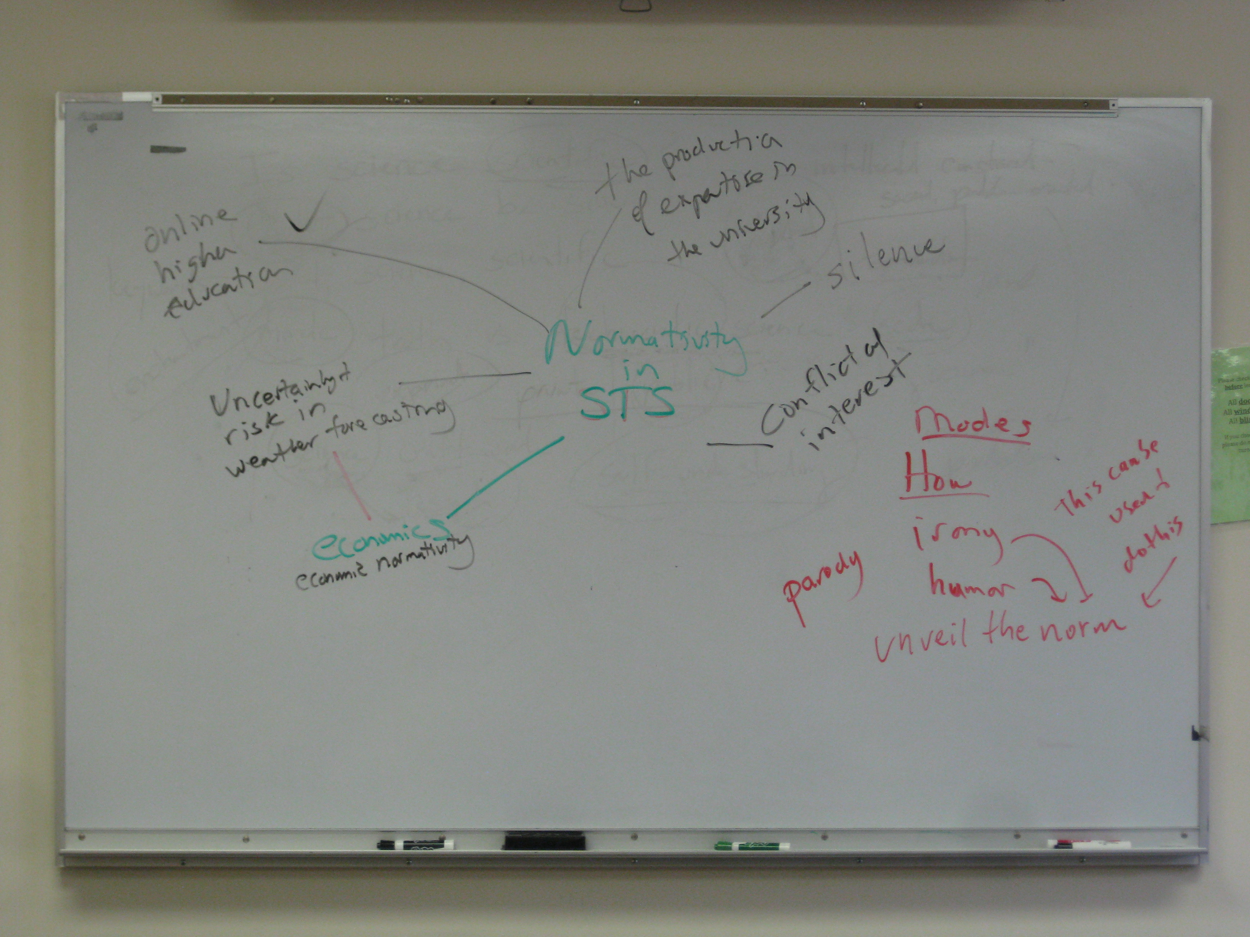

Feb. 11 Brainstorm result

Field Note: March 20 Tension About Format and Coherence

After our last meeting, it became challenging to get everyone to stay in class from 11:30 to noon to discuss our project. No judgment intended. People needed time to process and to research before discussing their ideas. Yet some people wanted to make sure that we had a plan moving forward. These conversations led to a meeting after class between four members of the team, two of whom felt we had no unified theme or narrative idea. They expressed concern that without a unifying vision, the project might simply be seen as a bunch of images or links without coherence. Another person felt that the more individualized approach meant that a unifying narrative would be challenging and that we should let the inidivual projects remain unencumbered by grand narratives.

David and Jen exchanged emails that illustrated the tension.

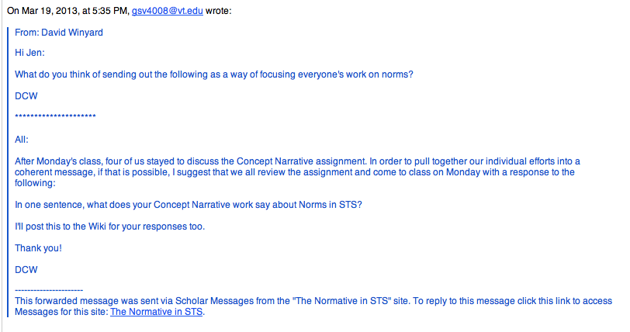

David:

Jen’s response, seen below, shows that she felt uncomfortable with the idea of distilling complex ideas into one sentence, especially since people were still trying to figure out their point of view on the subject. She felt like an organic approach to assembling the narrative would reveal connections, whereas David wanted these to be more explicit.
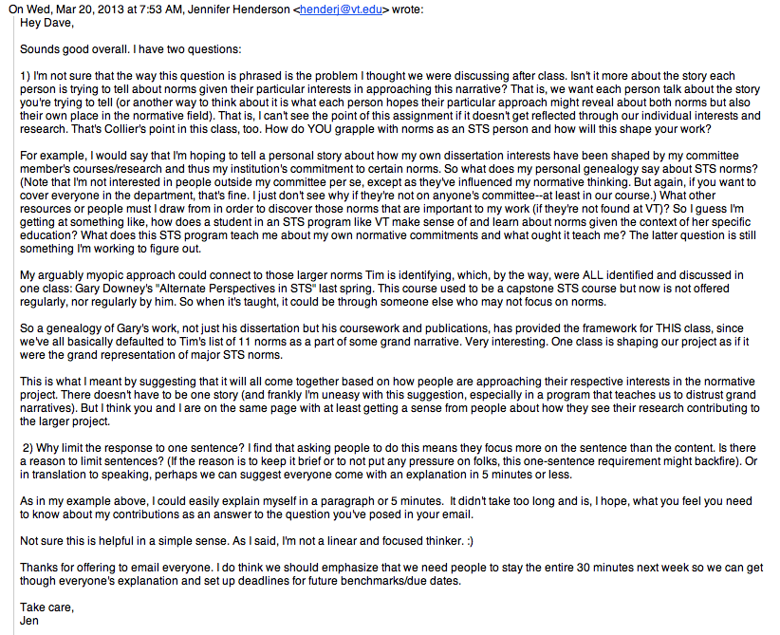

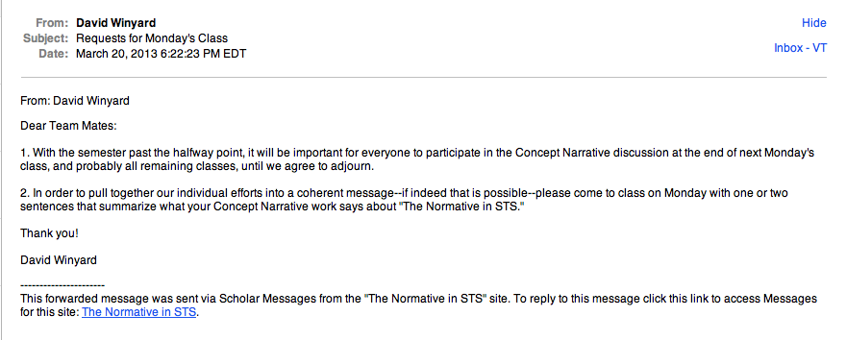

Field Note: March 25 Reporting to the Group

We took turns giving our one-sentence summary, which David recorded and rewrote for the planning wiki. Each person also reported on their status with their work, which revealed various stages of preparation. Some were still waiting on documents to analyze while others had made some headway with their narrative pieces. We made the decision to post our works in progress by Wednesday, April 10 so that we could begin stiching it together in anticipation of the May 3 deadline.

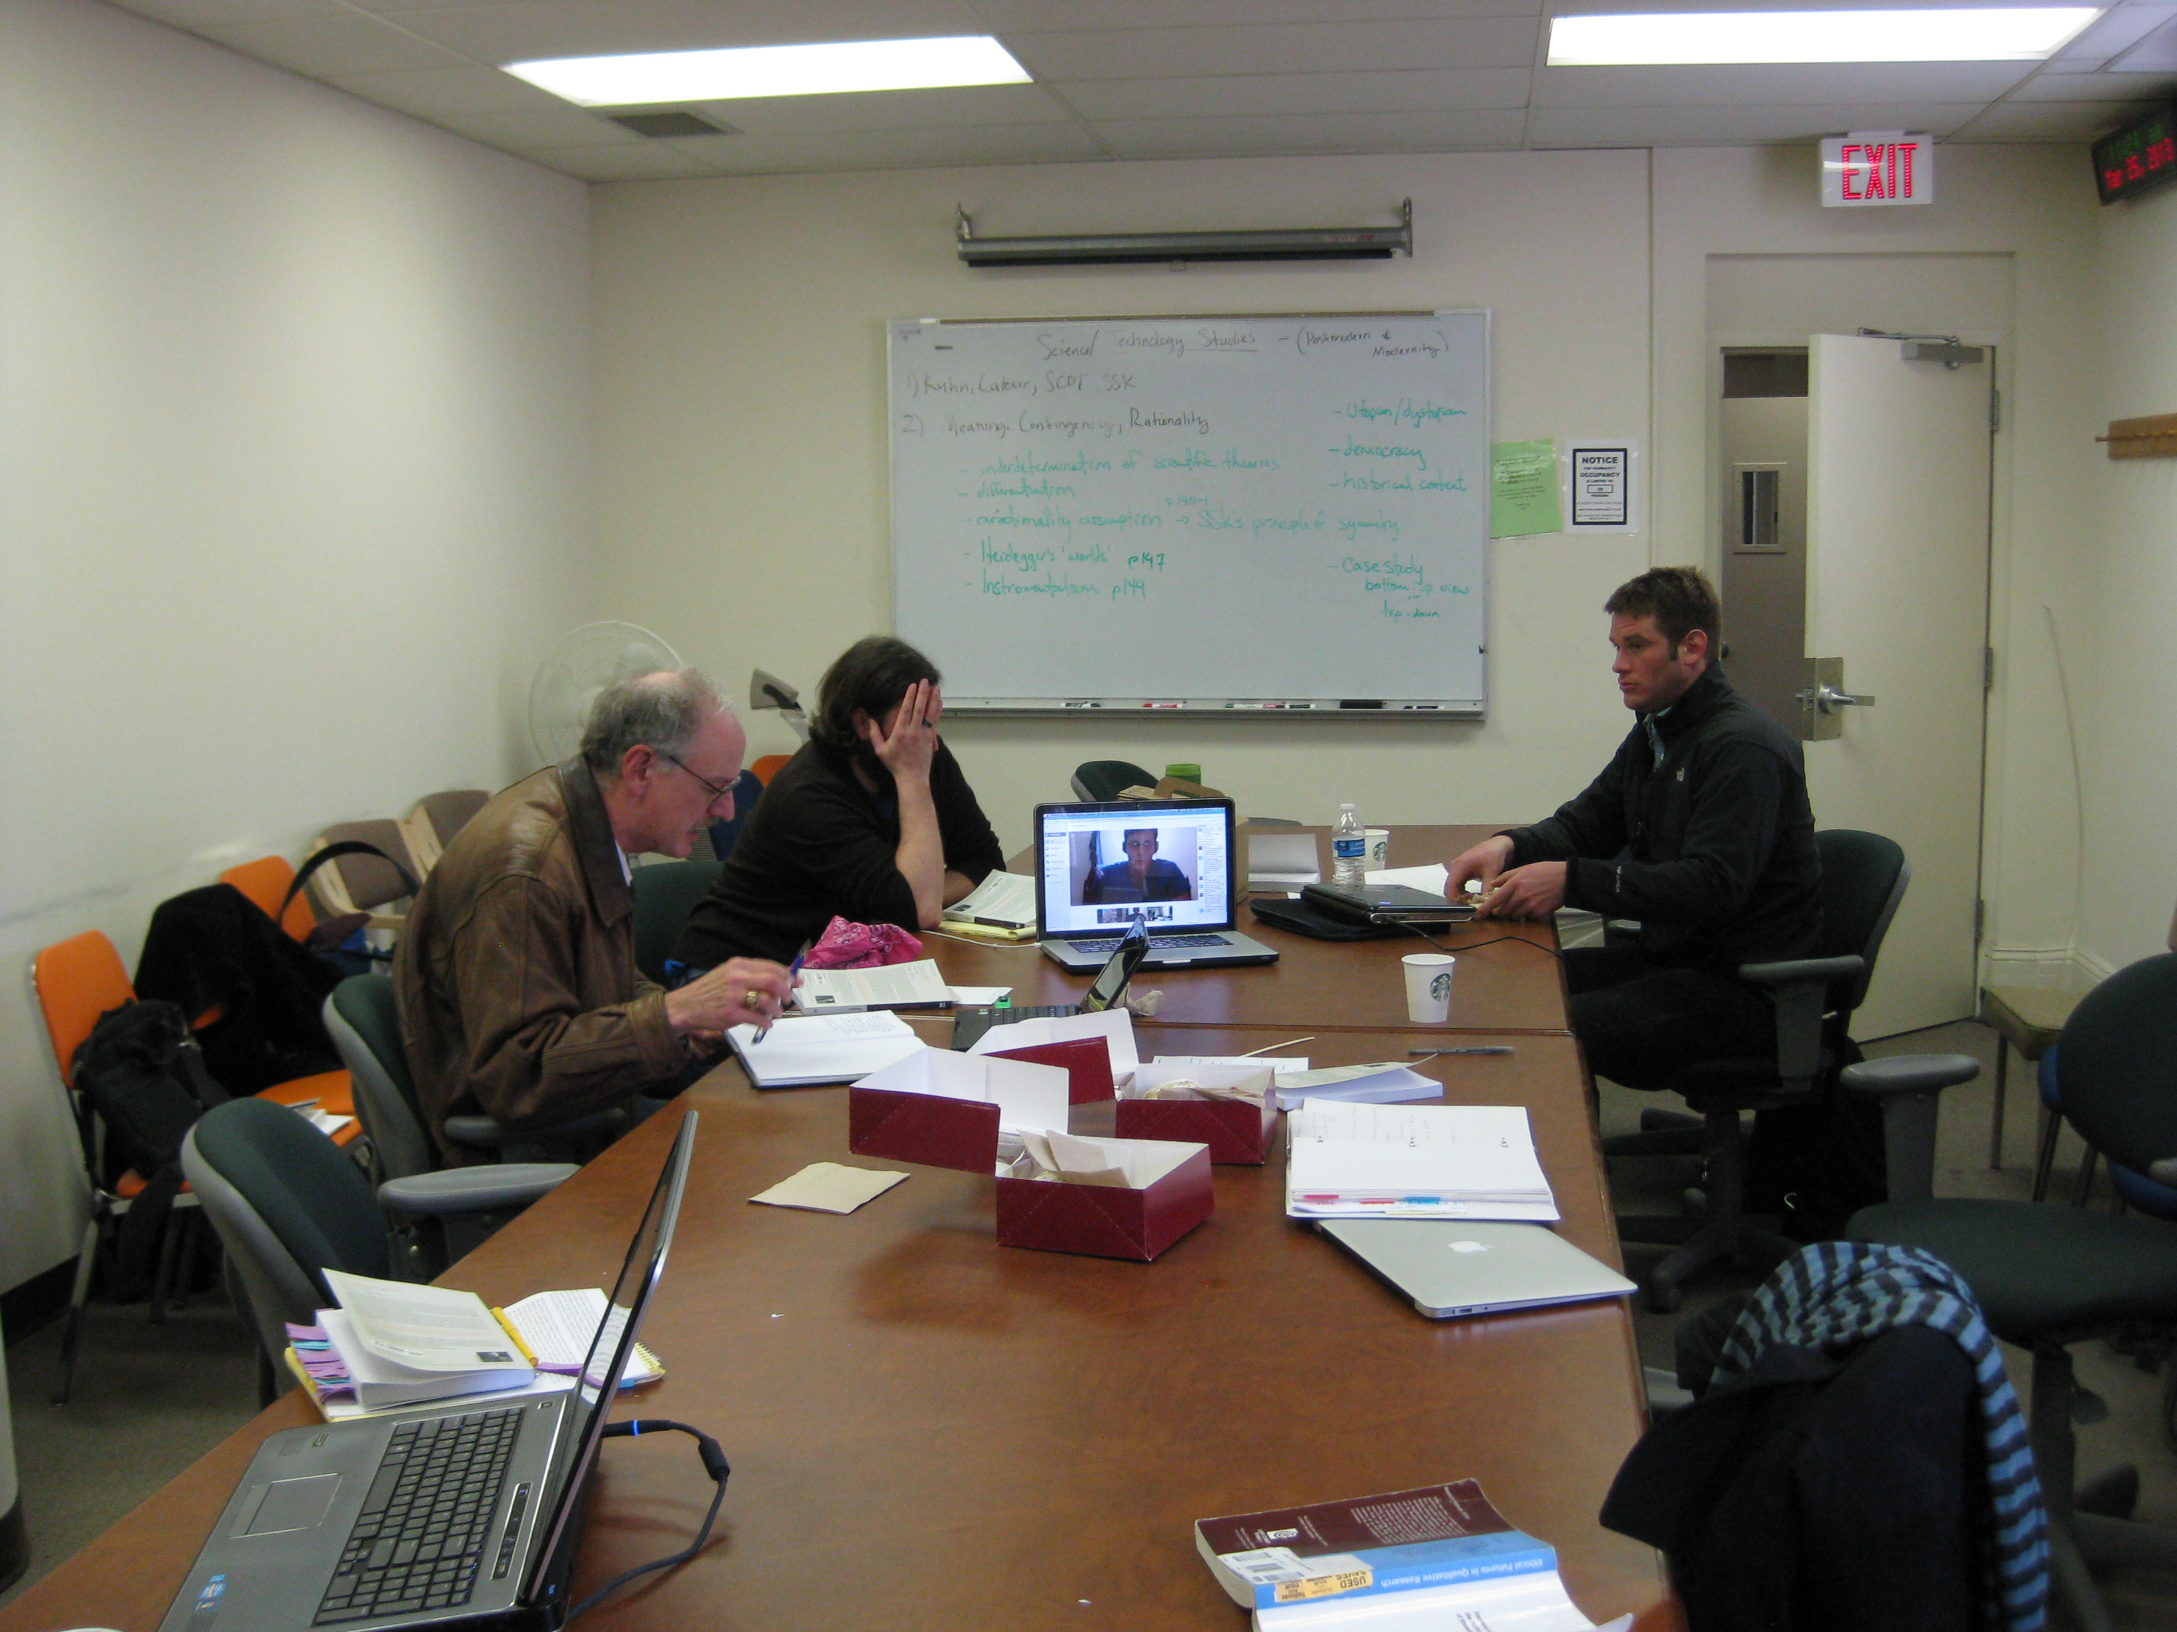

Field Note: April 15

